Label each side of every relation with x..y, where x is the minimum number of entities participating in the relationship and y is the maximum number of entities participating in the relationship.

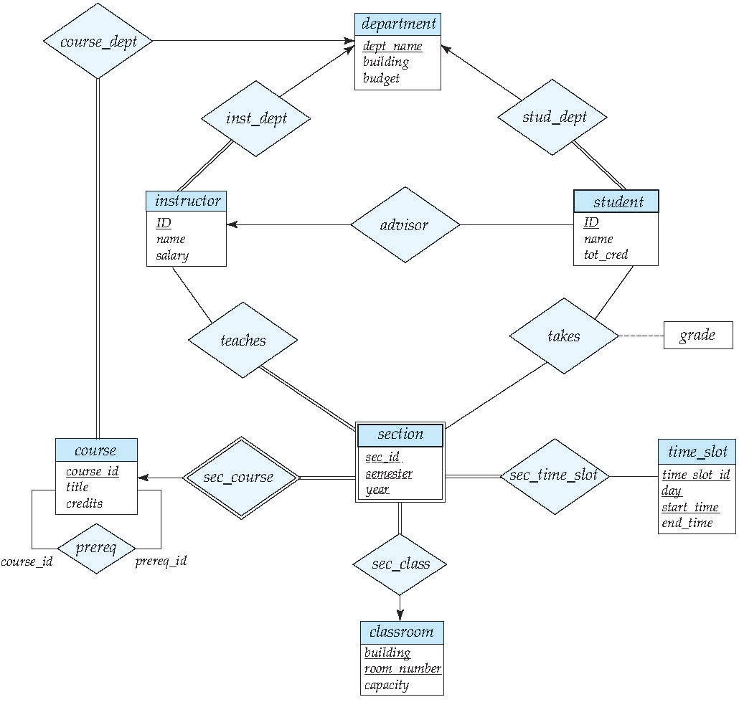Both x and y are usually 0, 1, or \*, with x<=y and y non-zero.